The University Of Azad Jammu & Kashmir

Student Name: Qurat Ul Ain Fatima
Roll No: 2024-SE-05
Course Title: Software construction & Development
Course Code: SE-3101
Course Instructor: Engr. Dr. Asma Javaid
Department: Software Engineering

LAB#04
Task 1: Online Doctor Appointment Management System

Objective
To identify different classes involved in an Online Doctor Appointment Management System, explain their functions, and design a UML class diagram.

Step 1: Identify the Classes
First, identify the main classes required to develop the system.
The following classes are used:
- Patient: Represents a person who wants to book an appointment with a doctor.
- Doctor: Represents a doctor who can view, accept, or reject appointment requests.
- Appointment: Stores appointment details such as date, time, and status.
- UserAccount: Manages registration and login information of patients and doctors.
- Schedule: Maintains the doctor's available and booked time slots.
- Notification: Sends appointment confirmation or rejection messages to patients.

Step 2: Patient Class
The Patient class stores information about patients.
Its main responsibilities are:
- Create an account.
- Log in to the system.
- Search for a doctor.
- Request an appointment.
- Receive appointment confirmation.

Step 3: Doctor Class
The Doctor class manages doctors' information and appointment requests.
Its responsibilities are:
- View appointment requests.
- Check available time slots.
- Accept appointment requests.
- Reject appointment requests if unavailable.

Step 4: Appointment Class
The Appointment class stores all information related to appointments.
It contains:
- Appointment ID.
- Appointment date.
- Appointment time.
- Appointment status.
It also manages appointment creation and status updates.

Step 5: UserAccount Class
This class manages user registration and authentication.
Its responsibilities are:
- Register a new account.
- Store username and password.
- Verify login information.

Step 6: Schedule Class
The Schedule class manages the doctor's availability.
Its responsibilities are:
- Display available time slots.
- Check doctor's availability.
- Reserve appointment slots.

Step 7: Notification Class
The Notification class sends messages to patients.
For example:
- Appointment accepted.
- Appointment rejected.
- Appointment confirmation.

Step 8: UML Class Diagram Description
The UML class diagram contains six classes:
- Patient
- Doctor
- Appointment
- UserAccount
- Schedule
- Notification
These classes are connected through relationships to represent how the appointment management system works.
A patient creates an account and requests an appointment. The doctor checks the schedule and accepts or rejects the request. Finally, the system sends an appointment status notification to the patient.
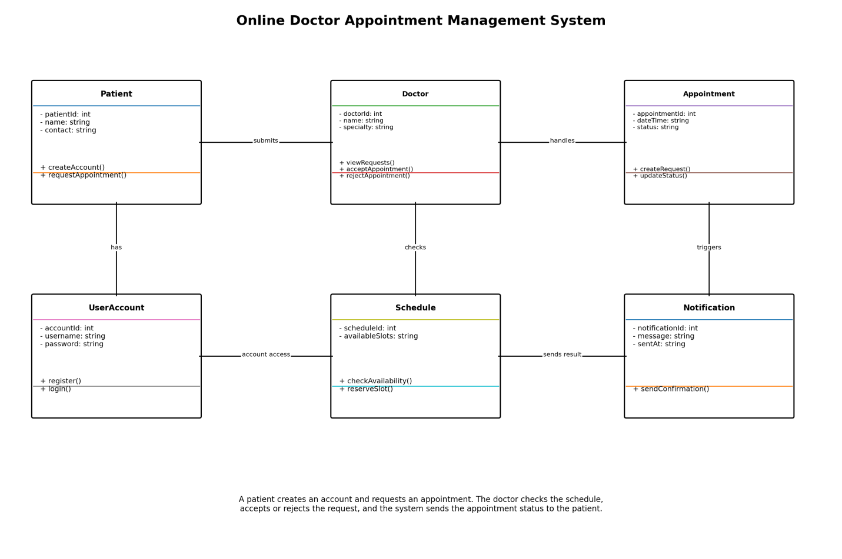

Task 2: Animal Inheritance

Objective
To implement a superclass named Animal and create two subclasses, Cat and Dog, using inheritance in C++.

Step 1: Create Superclass Animal
First, create a superclass named Animal.
This class contains two common functions:
- eat() – Allows an animal to eat food.
- sleep() – Allows an animal to sleep.
These functions are common to all animals.

Step 2: Create Subclass Cat
Create a subclass named Cat that inherits from the Animal class.
The Cat class has its own function:
- meow() – Displays the sound made by a cat.
The Cat class can also use the eat() and sleep() functions inherited from Animal.

Step 3: Create Subclass Dog
Create another subclass named Dog that inherits from Animal.
The Dog class has its own function:
- bark() – Displays the sound made by a dog.
The Dog class can also use the eat() and sleep() functions inherited from Animal.

Step 4: Create Main Function
Inside the main function:
- Create an object of Cat.
- Call its eat() function.
- Call its sleep() function.
- Call its meow() function.
- Create an object of Dog.
- Call its eat() function.
- Call its sleep() function.
- Call its bark() function.

Step 5: C++ Code
#include <iostream>
using namespace std;

// Superclass
class Animal
{
public:
void eat()
{
cout << "Animal is eating." << endl;
}

void sleep()
{
cout << "Animal is sleeping." << endl;
}
};

// Subclass Cat
class Cat : public Animal
{
public:
void meow()
{
cout << "Cat says Meow!" << endl;
}
};

// Subclass Dog
class Dog : public Animal
{
public:
void bark()
{
cout << "Dog says Woof!" << endl;
}
};

int main()
{
Cat c;
Dog d;

cout << "Cat Activities:" << endl;
c.eat();
c.sleep();
c.meow();

cout << "\nDog Activities:" << endl;
d.eat();
d.sleep();
d.bark();

return 0;
}

Step 6: UML Class Diagram Description
The Animal class is the superclass, while Cat and Dog are its subclasses.
- Animal contains eat() and sleep() functions.
- Cat inherits from Animal and contains meow().
- Dog inherits from Animal and contains bark().
Both subclasses can use the functions of the Animal superclass.
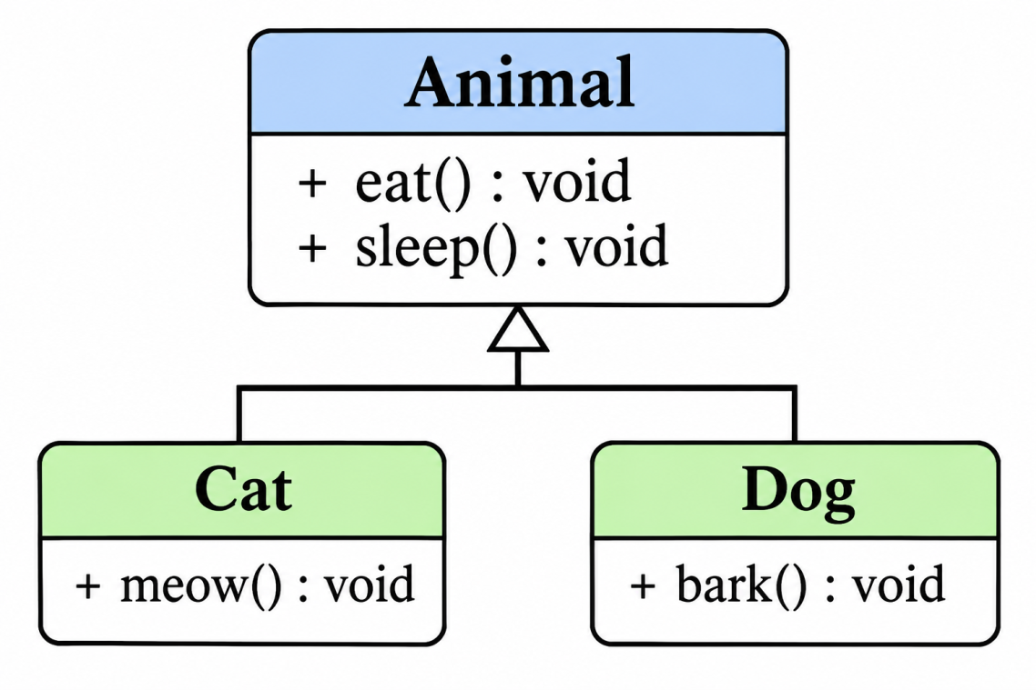

Step 7: Expected Output
Cat Activities:
Animal is eating.
Animal is sleeping.
Cat says Meow!

Dog Activities:
Animal is eating.
Animal is sleeping.
Dog says Woof!

Task 3: Shape Inheritance

Objective
To implement a superclass named Shape and create two subclasses, Triangle and Rectangle, using inheritance in C++. Calculate the area of both shapes by taking input from the user.

Step 1: Create Superclass Shape
First, create a superclass named Shape.
This class contains a common function named calculateArea().
The function will be overridden in the subclasses to calculate the area of different shapes.

Step 2: Create Subclass Triangle
Create a subclass named Triangle that inherits from Shape.
The Triangle class calculates the area using the formula:
Area of Triangle = ½ × Base × Height
It takes base and height values as input from the user.

Step 3: Create Subclass Rectangle
Create another subclass named Rectangle that inherits from Shape.
The Rectangle class calculates the area using the formula:
Area of Rectangle = Length × Width
It takes length and width values as input from the user.

Step 4: Create Main Function
Inside the main function:
- Create an object of Triangle.
- Take base and height as input.
- Calculate and display the triangle's area.
- Create an object of Rectangle.
- Take length and width as input.
- Calculate and display the rectangle's area.

Step 5: C++ Code
#include <iostream>
using namespace std;

// Superclass
class Shape
{
public:
virtual void calculateArea()
{
cout << "Calculating area..." << endl;
}
};

// Subclass Triangle
class Triangle : public Shape
{
public:
float base, height;

void calculateArea() override
{
cout << "Enter triangle base: ";
cin >> base;

cout << "Enter triangle height: ";
cin >> height;

float area = 0.5 * base * height;

cout << "Area of Triangle = " << area << endl;
}
};

// Subclass Rectangle
class Rectangle : public Shape
{
public:
float length, width;

void calculateArea() override
{
cout << "Enter rectangle length: ";
cin >> length;

cout << "Enter rectangle width: ";
cin >> width;

float area = length * width;

cout << "Area of Rectangle = " << area << endl;
}
};

int main()
{
Triangle t;
Rectangle r;

cout << "Triangle Area Calculation" << endl;
t.calculateArea();

cout << "\nRectangle Area Calculation" << endl;
r.calculateArea();

return 0;
}

Step 6: UML Class Diagram Description
The Shape class is the superclass, while Triangle and Rectangle are its subclasses.
- Shape contains the calculateArea() function.
- Triangle inherits from Shape and calculates the area using base and height.
- Rectangle inherits from Shape and calculates the area using length and width.
Both subclasses provide their own implementation of the calculateArea() function.
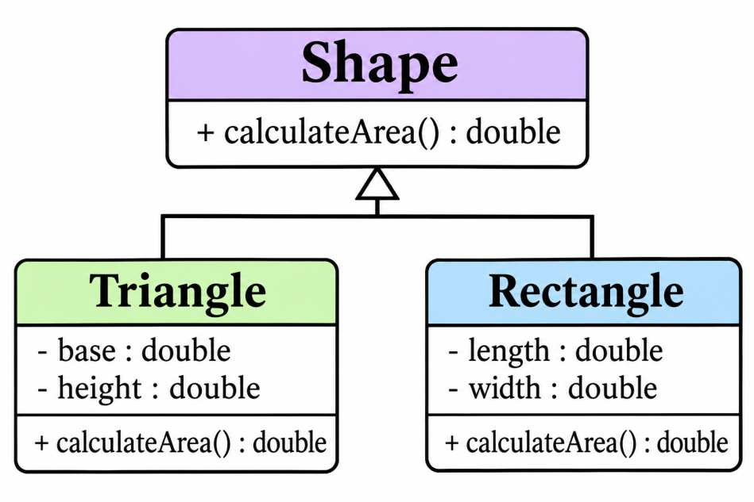

Step 7: Expected Output
For example, if the user enters:
- Triangle base = 10
- Triangle height = 5
- Rectangle length = 8
- Rectangle width = 4
The output will be:
Triangle Area Calculation
Enter triangle base: 10
Enter triangle height: 5
Area of Triangle = 25

Rectangle Area Calculation
Enter rectangle length: 8
Enter rectangle width: 4
Area of Rectangle = 32

Final Conclusion
In this lab, three important concepts of Software Construction and Development were studied.
Task | Topic | Main Concept
Task 1 | Online Doctor Appointment Management System | Classes and UML Class Diagram
Task 2 | Animal Inheritance | Inheritance in C++
Task 3 | Shape Inheritance | Inheritance and Area Calculation
Lab Requirements:
- Identify six classes and explain their functions for the Online Doctor Appointment Management System.
- Implement Animal, Cat, and Dog classes using inheritance in C++.
- Implement Shape, Triangle, and Rectangle classes using inheritance and calculate their areas through user input.

